PIRA 200
Electricity and Magnetism
Rods and Fur  Rods and Pivot  Soft Drink Can Electroscope  Charging by Induction  Charge Propelled Cylinder  Van de Graaff Generator  Hair on End  Electric Field Lines  Faraday's Ice Pail  Radio in a Cage  Point and Ball with Van de Graaff  Parallel Plate Capacitor  Capacitor with Dielectrics  Short a Capacitor  Light the Bulb  Resistance Model  Wire Coil in LN2  Conduction in Glass | Jacob's Ladder  Lemon Battery  Thermocouple  Ohm's Law  Fuse with Increasing Load  Kirchhoff's Voltage Law  Series and Parallel Circuits  Capacitor and Light Bulbs  Break a Magnet  Magnetic Domain Models  Paramagnetism and Diamagnetism  Curie Point  Meissner Effect  Oersted's Effect  Magnet and Iron Filings  Magnetic Field Around a Wire  Solenoid and Iron Filings  Magnets and Pivot  Cathode Ray Tube | Parallel Wires  Interacting Coils  Jumping Wire  Model Galvanometer  LR Time Constant on Scope  Series or Parallel Lamps w/Inductor  Induction Coil and Magnet  Mutual Induction Coils with Battery  Pendulum in Big Electromagnet  Magnets and Tubes  Faraday Repulsion Coil  Dissectible Transformer  Motor/Generator  RLC Resonance  EM Vectors  Induction Coil  Projected Spectrum w/Prism

Electricity and Magnetism | 5A10.10 | ELECTROSTATICS
Producing Static Charge

Rods and Fur
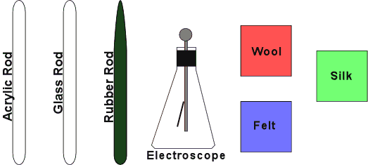 | Rub the wool felt cloth on the PVC rod to produce negative charge on the rod.  Rub the cellophane on the acrylic rod to produce positive charge on the rod.  Workshop Video

Electricity and Magnetism | 5A20.10 | ELECTROSTATICS
Coulomb's Law

Rods and Pivot
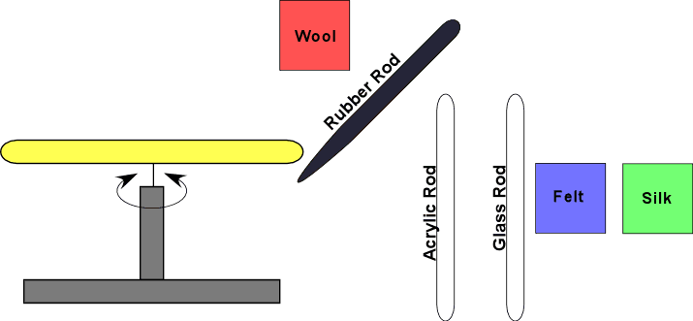 | Rub both ends of a rod and center it on the pivot. Rub the PVC rod (negative charge) with the felt or the acrylic rod (positive charge) with the cellophane.  Rub one end of a second rod and hold its charged end near the end of the rod on the pivot.  Workshop Video

Electricity and Magnetism | 5A22.25 | ELECTROSTATICS
Electrostatic Meters

Soft Drink Can Electroscope
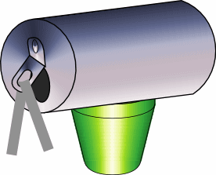 | The tab of the soft drink can supports the electroscope leaves in this simple version.  Workshop Video

Electricity and Magnetism | 5A40.10 | ELECTROSTATICS
Induced Charge

Charging by Induction
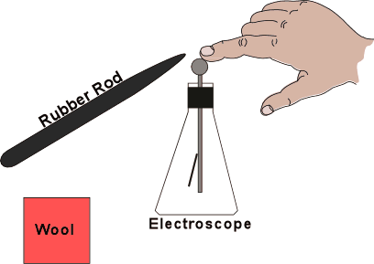 | Charging by induction with an electroscope for a charge indicator.  Workshop Video

Electricity and Magnetism | 5A40.20 | ELECTROSTATICS
Induced Charge

Charge Propelled Cylinder
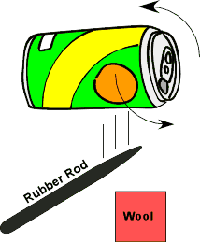 | Set an empty soda can on the table so the open end faces the students. Pull the can forward with induced charge. Switch to the oppositely charged rod and repeat.  Workshop Video

Electricity and Magnetism | 5A50.30 | ELECTROSTATICS
Electrostatic Machines

Van de Graaff Generator
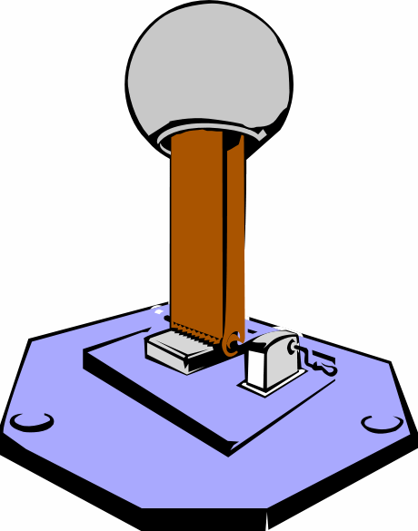 | Have student stand on platform and place hand on top of VDG. Do not remove hand from the surface. Turn on the VDG and observe their hair.  Turn off the VDG. Use grounding wire attached to base of generator to discharge the sphere, then allow student to withdraw hand.  Place various equipment items in kit one at a time on top on the VDG and turn it on.

Electricity and Magnetism | 5B10.10 |  | ELECTRIC FIELDS AND POTENTIAL
Electric Field

Hair on End
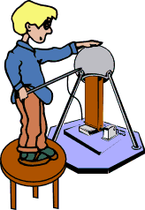 |  | Remove pointed metal items such as keys and microphones. Stand on the insulated stool. With the variable control fully counter-clockwise, turn the power on. Hold the pointed probe against the sphere while turning up the motor.  Place your other hand on the sphere before removing the probe. Do not remove your hand and stay away from anything metal. Allow yourself to charge up. Fine, clean, dry hair stands on end the best.  Try pointing at a student or the electrified strings.  To discharge without shocks, hold pointed probe against the sphere, remove other hand and turn off motor.

Electricity and Magnetism | 5B10.40 | ELECTRIC FIELDS AND POTENTIAL
Electric Field

Electric Field Lines
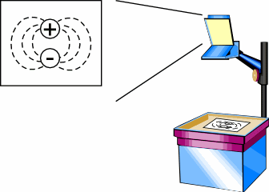 | Bits of material suspended in oil align with an applied electric field. Several pole arrangements are shown.

Electricity and Magnetism | 5B20.10 | ELECTRIC FIELDS AND POTENTIAL
Gauss' Law

Faraday's Ice Pail
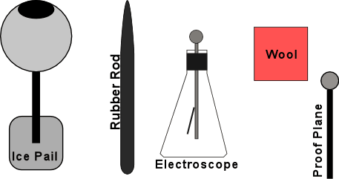 | Charge the sphere several times by rubbing a charged rod on its surface. Touch the proof plane to the outside of the sphere and then to the electroscope. The electroscope charges, indicating there is a charge on the outside of the sphere.  Repeat the same test on the inside of the sphere. The electroscope does not charge.

Electricity and Magnetism | 5B20.35 | ELECTRIC FIELDS AND POTENTIAL
Gauss' Law

Radio in a Cage
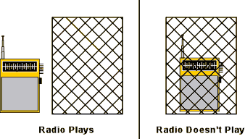 | Turn on the light and the radio. You should hear static that the radio picks up from the fluorescent light source. Place the Faraday cage over the radio and you hear nothing.  Workshop Video

Electricity and Magnetism | 5B30.35 | ELECTRIC FIELDS AND POTENTIAL
Electrostatic Potential

Point and Ball with Van de Graaff
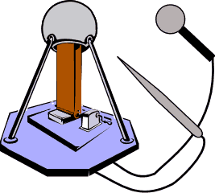 | Hold a ball close to a VDG and then bring a point close.  Workshop Video

Electricity and Magnetism | 5C10.20 | CAPACITANCE
Capacitors

Parallel Plate Capacitor
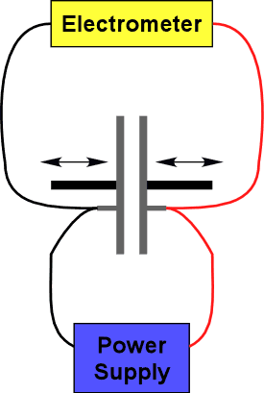 | Change the spacing of a charged parallel plate capacitor while it is attached to an electroscope.  Workshop Video

Electricity and Magnetism | 5C20.10 | CAPACITANCE
Dielectrics

Capacitor with Dielectrics
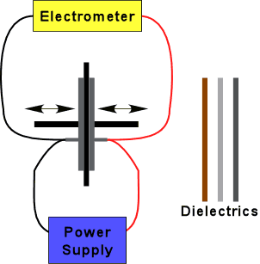 | Place a dielectric between the plates and push the plated against the dielectric. Turn on the power supply to charge the plates. Disconnect ground lead BEFORE turning the supply off. Slide the dielectric out of he plates and observe how the electroscope changes. Insert other dielectrics.  Workshop Video

Electricity and Magnetism | 5C30.20 | CAPACITANCE
Energy Stored in a Capacitor

Short a Capacitor
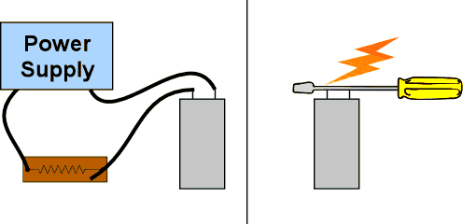 | Turn on the power supply to charge the 5600 microfarad capacitor through the power resistor. Remove the leads from the capacitor without touching the binding posts. Short the posts with the shaft of a screw driver (not the tip).  Workshop Video

Electricity and Magnetism | 5C30.30 | CAPACITANCE
Energy Stored in a Capacitor

Light the Bulb
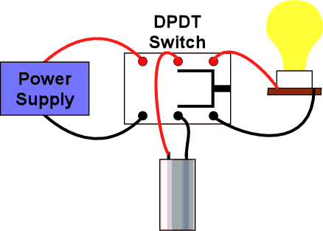 | Turn on the power supply to charge the capacitor through the power resistor. Turn off the power and disconnect the power supply. To discharge the capacitor, connect to the light bulb only. Do not short the capacitor. The 60W bulb lights for about 3 seconds. A 7.5 W bulb lights for about 20 seconds.  Workshop Video

Electricity and Magnetism | 5D10.40 | RESISTANCE
Resistance Characteristics

Resistance Model
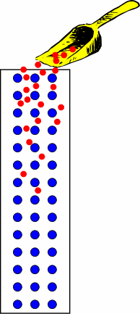 | Ball bearings are rolled down an inclined bed of nail to simulate current flow in a wire.  Workshop Video

Electricity and Magnetism | 5D20.10 | RESISTANCE
Resistivity and Temperature

Wire Coil in LN2
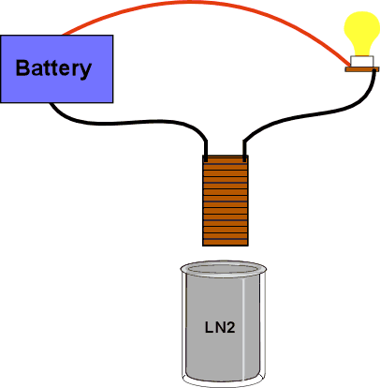 | Set up as shown. Place the coil into the LN2. Watch the light bulb get brighter as the coil cools.  Workshop Video

Electricity and Magnetism | 5D20.60 | RESISTANCE
Resistivity and Temperature

Conduction in Glass
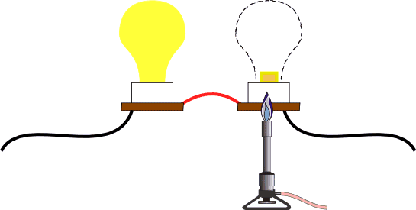 | A light bulb is smashed with a mallet and the filament is cut off. Then, the glass stem is heated with a blow torch.  Workshop Video

Electricity and Magnetism | 5D40.10 | RESISTANCE
Conduction in Gases

Jacob's Ladder
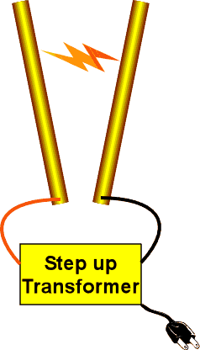 | This is a step up transformer. CAUTION: LETHAL VOLTAGE  Turn on the power and the discharge will travel up the wires. The distance between the wires is the critical adjustment. The wires should not be moving.  This does not work will on humid days. Unplug after use so that students don't inadvertently play with it.  Workshop Video

Electricity and Magnetism | 5E40.25 | ELECTROMOTIVE FORCE AND CURRENT
Cells and Batteries

Lemon Battery
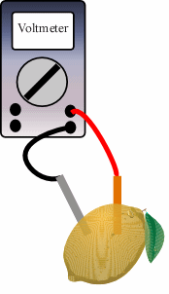 | Copper and Zinc electrodes in a lemon are connected to a digital meter.  Workshop Video

Electricity and Magnetism | 5E50.10 | EMF AND CURRENT
Thermoelectricity

Thermocouple
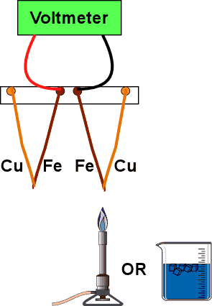 | A voltmeter is connected to the iron wires of two copper-iron wire junctions hanging from a stand. Light the Bunsen burner and heat one of the junctions, watching the voltmeter. You can also immerse a junction in ice.

Electricity and Magnetism | 5F10.10 | DC CIRCUITS
Ohm's Law

Ohm's Law
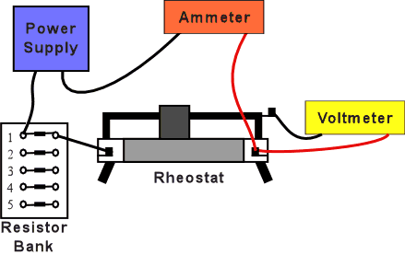 | Digital meters measure the current and the voltage in a simple circuit of a battery and resistor. The rheostat is adjusted so that the meters read the same, differing only by a factor of 1000. The battery pack contains six 1.5 volt batteries in series. Change the number of batteries in the circuit OR change the resistance and observe that the meters change proportionally.  Workshop Video

Electricity and Magnetism | 5F15.35 | DC CIRCUITS
Power and Energy

Fuse with Increasing Load
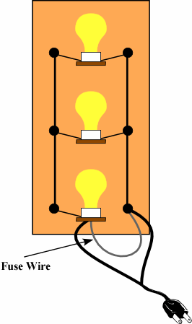 | A fuse wire will eventually fail when the load on the circuit is increased.  Workshop Video

Electricity and Magnetism | 5F20.10 | DC CIRCUITS
Circuit Analysis

Kirchhoff's Voltage Law
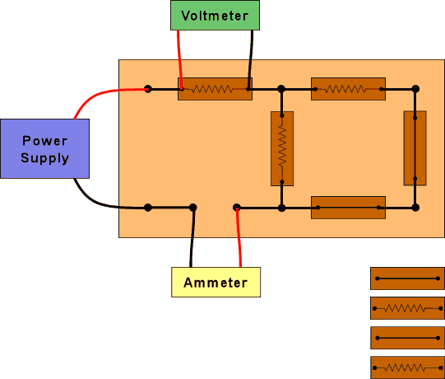 | Measure the voltage at different places in the circuit and show that the sum is zero. There are many possible combinations of components.  Workshop Video

Electricity and Magnetism | 5F20.50 | DC CIRCUITS
Circuit Analysis

Series and Parallel Circuits
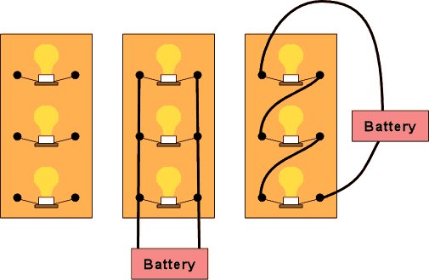 | If the combined series and parallel boards are confusing, try the separate boards.  Workshop Video

Electricity and Magnetism | 5F30.10 | DC CIRCUITS
RC Circuits

Capacitor and Light Bulb
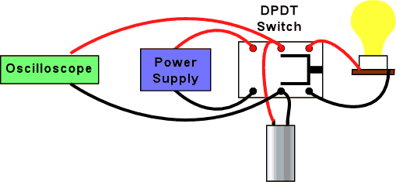 | A 5600 microfarad capacitor, a light bulb, and a 120 V dc supply in series show a long time constant where the bulb dims as the capacitor charges.

Electricity and Magnetism | 5G10.20 | MAGNETIC MATERIALS
Magnets

Break a Magnet
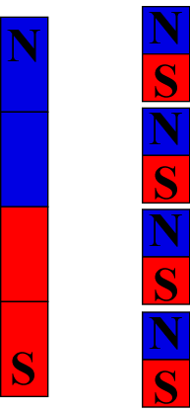 | A broken magnet still exhibits north and south poles.  Workshop Video

Electricity and Magnetism | 5G20.30 | MAGNETIC MATERIALS
Magnetic Domains and Magnetization

Magnetic Domain Models
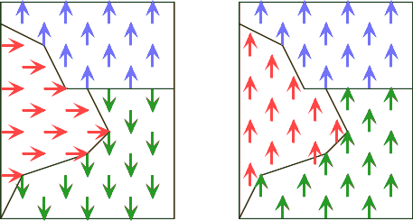 | There are two types of arrays: 1) Coplanar to show domains and 2) non-coplanar (random orientation). Bring a magnet near each array.

Electricity and Magnetism | 5G30.10 | MAGNETIC MATERIALS
Paramagnetism and Diamagnetism

Paramagnetism and Diamagnetism
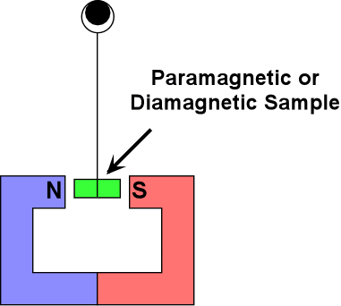 | Paramagnetic and diamagnetic crystals are inserted between the poles of a large magnet or electromagnet.  Workshop Video

Electricity and Magnetism | 5G50.10 | MAGNETIC MATERIALS
Temperature and Magnetism

Curie Point
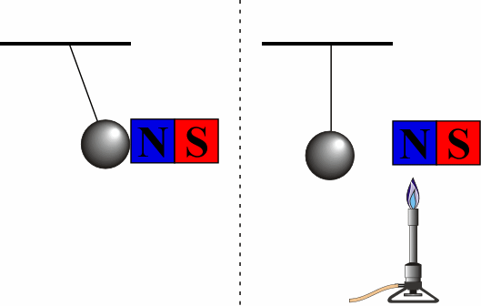 | Iron under magnetic attraction is heated until it falls away. Upon cooling it is again attracted.  Workshop Video

Electricity and Magnetism | 5G50.50 | MAGNETIC MATERIALS
Temperature and Magnetism

Meissner Effect
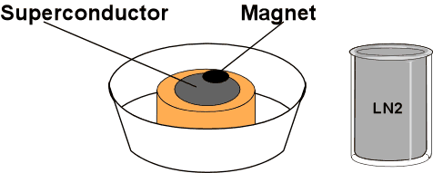 | Place a magnet on warm superconducting disk to show how nothing happens, then remove. Add LN2 to the Styrofoam container holding the super conducting disk. When the boiling stops, the disk is cold. Use the plastic tweezers to place one of the magnets on the disk. The magnet will float above the disk.  Workshop Video

Electricity and Magnetism | 5H10.20 | MAGNETIC FIELDS AND FORCES
Magnetic Fields

Oersted's Effect
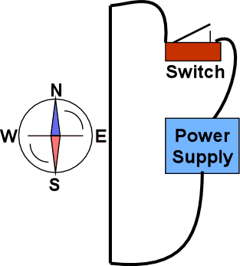 | Turn the compass needle so it is approximately parallel to the wire. Close the switch to send the current through the wire for about 5-10 sec. The compass will align itself with the magnetic field.  Workshop Video

Electricity and Magnetism | 5H10.30 | MAGNETIC FIELDS AND FORCES
Magnetic Fields

Magnet and Iron Filings
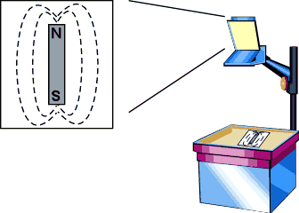 | Sprinkle iron filings on the Plexiglas plate. Tap the Plexiglas to encourage alignment.  Workshop Video

Electricity and Magnetism | 5H15.10 | MAGNETIC FIELDS AND FORCES
Fields and Currents

Magnetic Field around a Wire
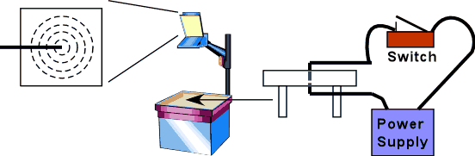 | Sprinkle iron filings on the Plexiglas. Hold down the switch briefly connecting the bottom while tapping the Plexiglas to encourage alignment.  Workshop Video

Electricity and Magnetism | 5H15.40 | MAGNETIC FIELDS AND FORCES
Fields and Currents

Solenoid and Iron Filings
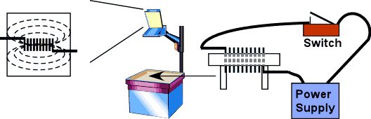 | Sprinkle iron filings on the Plexiglas. Hold down the tap switch briefly connecting the bottom while tapping the Plexiglas to encourage alignment.  Workshop Video

Electricity and Magnetism | 5H20.10 | MAGNETIC FIELDS AND FORCES
Forces on Magnets

Magnets and Pivot
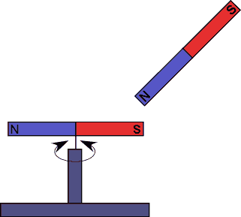 | One magnet is centered on a pivot. Hold one end of the second magnet near one end of the magnet on the pivot. Repeat with the opposite end.  Workshop Video

Electricity and Magnetism | 5H30.10 | MAGNETIC FIELDS AND FORCES
Force on Moving Charges

Cathode Ray Tube
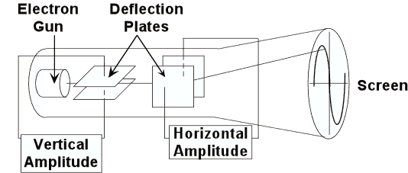 | Plug in the cathode ray tube. Deflect the beam of the CRT by holding a permanent magnet near the edge of the tube. If the beam disappears, you are holding the magnet too close.  OR, deflect the beam by attaching a battery to the binding posts and adjusting the variable control knob.  OR connect the battery directly to the deflection plate terminals.  Workshop Video

Electricity and Magnetism | 5H40.10 | MAGNETIC FIELDS AND FORCES
Forces on Current in Wires

Parallel Wires
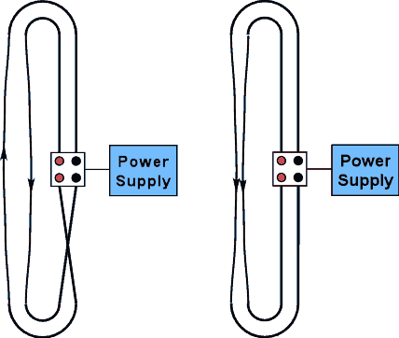 | Two insulated wires hang from a frame. Turn on the switch. Wires will attract or repel each other. Turn off the switch and reverse the leads in the binding posts. Turn the switch on. Wires will repel or attract each other.  Workshop Video

Electricity and Magnetism | 5H40.15 | MAGNETIC FIELDS AND FORCES
Forces on Current in Wires

Interacting Coils
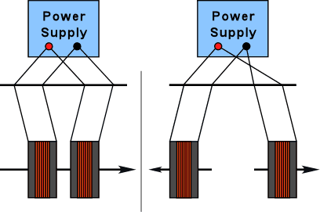 | Hang two coils from a support rod. Connect the DC power supply so that the current is in the same direction in both coils and watch them attract. Connect the DC power supply in opposite directions in the coils and watch them repel. A good storage battery can be used instead of the power supply.  Workshop Video

Electricity and Magnetism | 5H40.30 | MAGNETIC FIELDS AND FORCES
Forces on Current in Wires

Jumping Wire
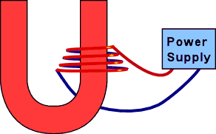 | A long wire is coiled around one pole of a permanent magnet. Close the switch. The wire collapses into the magnet. Turn the coil over and repeat. The wire "jumps" out of the magnet.  Workshop Video

Electricity and Magnetism | 5H50.10 | MAGNETIC FIELDS AND FORCES
Torques on Coils

Model Galvanometer
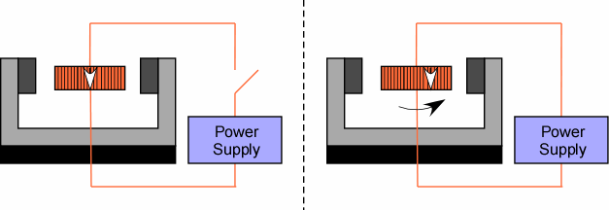 | A crude galvanometer with a large coil and magnet demonstrates the essentials.

Electricity and Magnetism | 5J20.10 | INDUCTANCE
LR Circuits

LR Time Constant on Scope
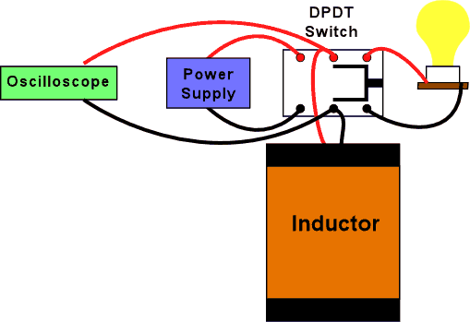 | A plug in circuit board with a make before break switch for showing slow RL time constants on the oscilloscope.  Workshop Video

Electricity and Magnetism | 5J20.20 | INDUCTANCE
LR Circuits

Series or Parallel Lamps w/Inductor
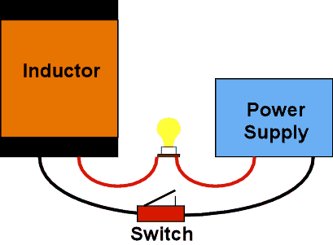 | Two lamps are used to indicate voltage across and current through a large electromagnet. Do this with the iron core in and then with the iron core removed.

Electricity and Magnetism | 5K10.20 | ELECTROMAGNETIC INDUCTION
Inducted Current and Forces

Induction Coil and Magnet
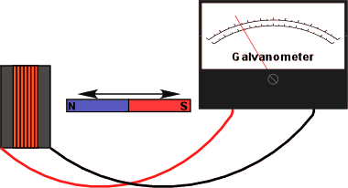 | Move the magnet in and out of the coil connected to the galvanometer.

Electricity and Magnetism | 5K10.30 | ELECTROMAGNETIC INDUCTION
Inducted Current and Forces

Mutual Induction Coils with Battery
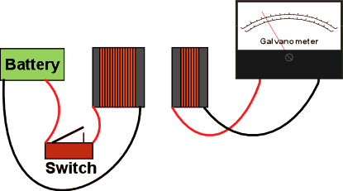 | Two coils face each other, one attached to a galvanometer, the other to a battery and tap switch. Coupling can be increased with various cores. Aluminum, laminated iron, and other solid iron cores are available.

Electricity and Magnetism | 5K20.10 | ELECTROMAGNETIC INDUCTION
Eddy Currents

Pendulum in Big Electromagnet
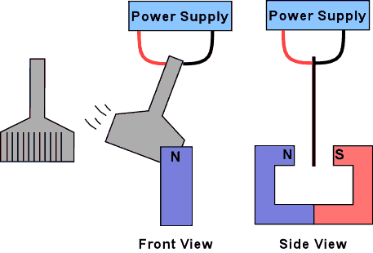 | Show that a solid copper plate swings between the poles of the electromagnet when the power is off. Turn on the power. Displace the pendulum and let it swing. It stops dead between the poles. Repeat with the slotted plate, ring and slit ring. Cannot leave the power on.  Workshop Video

Electricity and Magnetism | 5K20.25 | ELECTROMAGNETIC INDUCTION
Eddy Currents

Magnets and Tubes
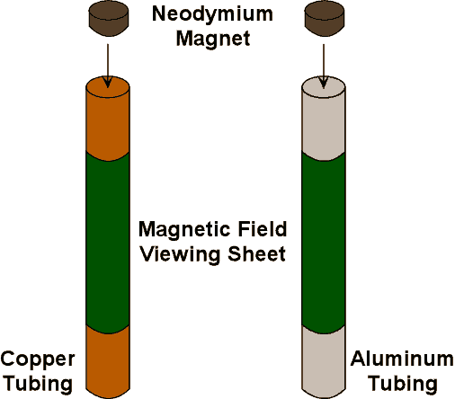 | Drop magnets simultaneously down the copper and stainless steel tube. It takes approximately 3 seconds for the magnet to fall through the three foot copper tube. Dummy magnets are also available. Aluminum tubes will also show damping.  Workshop Video

Electricity and Magnetism | 5K20.26 | ELECTROMAGNETIC INDUCTION
Eddy Currents

Faraday Repulsion Coil
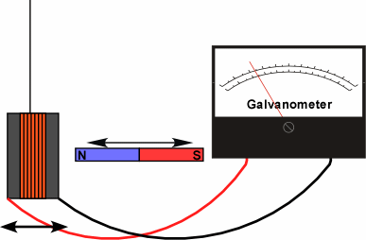 | A magnet is inserted and withdrawn from a solid and split ring on a bifilar suspension. It is possible to "pump" the solid ring.  Wokshop Video

Electricity and Magnetism | 5K30.20 | ELECTROMAGNETIC INDUCTION
Transformers

Dissectible Transformer
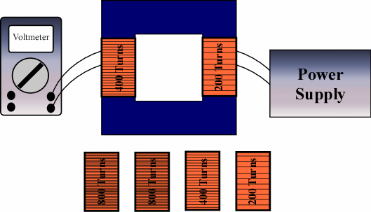 | Voltages can be shown on the primary and secondary coils of a dissectible transformer.  Wokshop Video

Electricity and Magnetism | 5K40.40 | ELECTROMAGNETIC INDUCTION
Motors and Generators

Motor / Generator
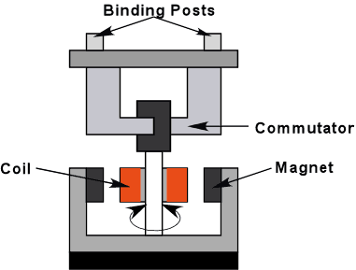 | Use the double throw switch to connect the battery to the motor. The 500 gram mass will rise. Switch to neutral and let the mass fall halfway down to build up speed. Switch to light bulb and bulb will light.  Wokshop Video

Electricity and Magnetism | 5L20.20 | AC CIRCUITS
RLC Circuits - AC

RLC Resonance
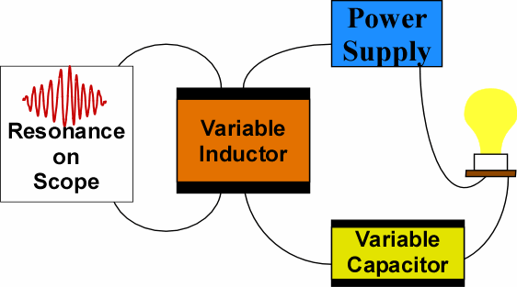 | The light bulb in a RLC circuit glows when the inductor core is moved through resonance.  Also, RLC resonance shown on an oscilloscope.

Electricity and Magnetism | 5N10.80 | ELECTROMAGNETIC RADIATION
Transmission Lines and Antennas

EM Vectors
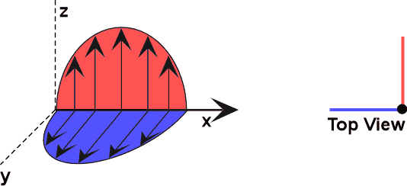 | A dynamic model for demonstrating electric and magnetic vectors in an electromagnetic field.

Electricity and Magnetism | 5N20.10 | ELECTROMAGNETIC RADIATION
Tesla Coil

Induction Coil
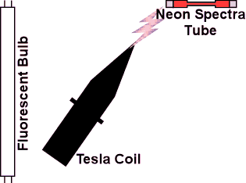 | Turn on the Tesla coil. Take the spectra tube and hold it within 2 feet of the Tesla coil. Vary the distance. Do the same thing with the fluorescent tube. Using the grounding wire on the end of the tube can help avoid unpleasant shocks. Discuss shocks vs. burns and high frequency AC.  Workshop Video

Electricity and Magnetism | 5N30.10 | ELECTROMAGNETIC RADIATION
Electromagnetic Spectrum

Projected Spectrum w/Prism
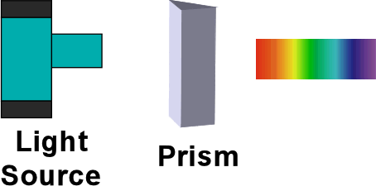 | White light is projected through a high dispersion prism and onto a screen.  Workshop Video

